An Explainable Survival-Analysis Framework for Predicting Time-to-Employment of IT Graduates in Sri Lanka

M. S. F. Shazna
School of Computing and Engineering
National Institute of Business Management
Colombo, Sri Lanka
shaznasalman10@gmail.com
L. S. Chathurika
School of Computing and Engineering
National Institute of Business Management
Colombo, Sri Lanka
sumudu@nibm.lk
[External author's name]
[Department]
[Organization]
[City, Country]
[email address]

Abstract—Sri Lanka produces about 17,000 information technology graduates a year, yet a graduate has no individual, evidence-based view of how long the search for a first IT job is likely to take. Existing employability tools predict a category or rank job matches, and they discard graduates who are still searching. This study developed and evaluated an explainable survival-analysis framework that estimates the time to a first IT job for Sri Lankan IT graduates. Following the Design Science Research Methodology, responses from 1,175 graduates and final-year students and 245 employers were collected together with 324 real entry-level job advertisements. Cox, Elastic Net Cox, three accelerated failure time models and DeepSurv were fitted on a training set, compared on a validation set under a selection rule fixed in advance, and the selected model was evaluated once on a locked test set. The median time to a first IT job was four months, and grade point average and internship experience were the factors most clearly associated with a shorter search. The selected log-normal accelerated failure time model reached a concordance index of 0.69 on validation and 0.62 on the test set, ranking graduates better than chance but under-predicting employment; neural models did not perform better. Graduates rated themselves below employer expectations on 25 of 26 skills, most in cloud computing, software testing and DevOps. The framework is delivered as a web application that gives an individual time range with its uncertainty, explanations, what-if scenarios and market comparisons. On the same test graduates it ranked graduates better than a general-purpose large language model, ChatGPT (concordance index 0.62 against 0.54). Twelve users gave it a mean System Usability Scale score of 76.3, above the benchmark of 68.
Keywords—graduate employability, survival analysis, time-to-employment, accelerated failure time model, explainable artificial intelligence, decision support system, Sri Lanka

Introduction
The information technology and business process management (IT-BPM) sector is one of Sri Lanka's fastest-growing export industries, and its growth depends on a steady supply of industry-ready graduates. Sri Lankan universities and higher-education institutes produce an estimated 17,000 IT and computing graduates each year [1]. Yet youth unemployment (ages 15-24) stood at 19.7% in the first quarter of 2025 [2], and industry and academic sources continue to report a persistent gap between the skills graduates hold and the skills employers require, particularly in cloud computing, DevOps and cybersecurity [1], [3], [4].
For an individual graduate, this gap appears as uncertainty: how long will it take to find a first IT job, and which change to the profile would shorten that search? Industry reports and tracer studies answer at the population level, but no tool translates them into an individual estimate. The closest Sri Lankan system predicts a career-path category from 820 IT employee profiles [5]; it does not estimate time, and like other classification approaches it must either discard graduates who are still searching or count them as failures. Existing systems also rarely combine graduate data with independent employer and job-market data, and none show what they offer beyond a general-purpose large language model (LLM) that a graduate can already consult.
This study addresses these problems with survival analysis, which models the time until an event and uses the partial information carried by censored cases, here graduates still searching when surveyed. Its objectives were to (1) identify the academic, technical, professional and preparation factors associated with time to a first IT job; (2) measure the alignment between graduate profiles, employer requirements and job advertisements; (3) develop and compare linear, regularised, parametric and neural survival models; and (4) deliver the selected model in an explainable web-based decision-support application. The contributions of the paper are:
- to our knowledge, the first survival analysis of time to a first IT job among Sri Lankan IT graduates, on 885 modelling graduates;
- a comparison of seven survival models under a selection rule fixed before analysis, with the selected model evaluated once on a locked test set;
- a triangulated picture of entry-level IT skill gaps from graduates, employers and real job advertisements; and
- a reproducible decision-support artifact that reports ranges with their uncertainty and explanations limited to factors a graduate can change.
Section II reviews related work, Section III describes the methodology, Section IV presents the solution, Section V reports the evaluation, Section VI discusses the findings and Section VII concludes with recommendations.

Literature Review

Graduate Employability and Skills Alignment
Employability is widely treated as a multidimensional construct combining academic achievement, technical and soft skills, certifications and practical industry exposure [6], [7]. This rules out any single proxy, such as grade point average (GPA) alone, as a basis for prediction. A bibliometric analysis of more than 10,000 publications found a persistent mismatch between curricula and job-market requirements [3], and Sri Lankan labour-market mapping identified cloud computing as the most in-demand skill area [4]. Recent local studies confirm that the mismatch remains current, from the perspective of both graduates [8] and higher-education administrators [9], but they are descriptive and offer no individual prediction.

Machine Learning for Employability and Career Guidance
AI-based systems address several separate tasks: resume parsing and job matching [10], [11], job filtering for working IT professionals [12], career guidance and skill-gap detection [13], [14], and predictive skill-gap analytics on undergraduate survey data [15], [16]. The strongest local precedent is an ensemble model that predicts career paths of Sri Lankan IT undergraduates from 31 attributes [5]. Across this work the output is a label, a ranking or a match score; none estimates how long a graduate is likely to search, none uses information from graduates still searching, and few report accuracy on held-out data in a form that reflects uncertainty.

Survival Analysis and Explainable AI
Survival analysis models time to an event while accounting for censoring. It has been used to study graduates' time to first employment in Ethiopia, with GPA and internships among the significant factors [17], and time to graduate-level employment in the UK [18], but not for IT graduates in Sri Lanka or with predictive evaluation on held-out graduates. The Cox proportional hazards model estimates covariate effects on the hazard without assuming a distribution of time and remains the most widely used approach [19]; penalised Cox models handle many predictors relative to events; accelerated failure time (AFT) models describe time directly, so that a factor multiplies the expected time by a time ratio [20]. DeepSurv replaces the linear risk function of the Cox model with a neural network, but deep survival models generally need large samples to outperform classical ones [21]. Explainable AI makes predictions interpretable either globally or for one individual [22]; hazard and time ratios are directly interpretable, and SHAP values provide comparable local explanations for neural models [23].

Research Gap
Table I compares the closest systems with the present study. No reviewed study applies survival analysis to Sri Lankan IT graduates, combines graduate, employer and job-advertisement data in one framework, or turns an individual time estimate into quantified, counterfactual guidance.
- Comparison of Related Systems with This Study
Capability | Rukais et al. [5] | ITConnect [12] | Scopira [14] | Commercial tools | This study
Sri Lankan IT focus | Yes | Yes | No | No | Yes
Predicts time to employment | No | No | No | No | Yes
Uses censored (still searching) cases | No | No | No | No | Yes
Range with uncertainty | No | No | No | No | Yes
Individual explanation and what-if | No | No | Partial | Partial | Yes
Employer and job-advert data | No | Partial | Partial | Partial | Yes

Methodology

Research Design
The study adopts a pragmatist philosophy and a deductive, quantitative approach combined with artifact development, following the Design Science Research Methodology (DSRM) [24]. Problem identification and the definition of objectives draw on the review above; design and development cover the instruments, the modelling pipeline and the application; demonstration and evaluation use the real survey data; and this paper forms part of the communication stage. The analysis plan, the primary metric and the model-selection rule were fixed before the data were analysed, following current guidance on reporting prediction models [25] and on avoiding selective reporting of concordance measures [26].

Data Collection
Three sources were triangulated. A 47-item graduate questionnaire captured the degree, GPA, internships, certifications, projects, 17 technical and 9 soft-skill self-ratings, preparation activities and the months of degree completion and of the first IT job. A 21-item employer questionnaire captured the importance of the same 26 skills and of hiring factors. Finally, 324 entry-level IT job advertisements posted by 211 employers between 12 July and 11 October 2026 were coded to the same 26-skill vocabulary by fixed keyword rules; agreement with an independent hand coder on 36 adverts was almost perfect (κ = 0.83; precision 0.96, recall 0.80), although broadly worded skills such as critical thinking are under-counted. Respondents were reached through university and professional networks using purposive, convenience and snowball sampling, so the sample is non-probability. Six experts (two lecturers, a survival-analysis researcher and three industry practitioners) reviewed the instruments, and a pilot with 21 graduates and 9 employers, excluded from the main sample, confirmed that duration and event could be derived for every graduate. Main-study responses were collected through Google Forms, and every response was given the end of collection (6 October 2026) as its survey date. Consent was recorded for every response, and no names or contact details were requested.
Stakeholders shaped the design at each stage. The supervisor's reviews of the proposal and draft chapters led to concise, measurable objectives, analysis techniques linked to each research question and the rule that no graduate is reused across the training, validation and test sets. The expert reviewers' recommendations were adopted in the instruments and the artifact: month-and-year questions for degree completion and the first job, one 26-skill vocabulary shared by graduates, employers and job advertisements, associational wording that presents the output as guidance rather than judgement, and a link from every skill gap to a learning resource. Employers supplied the importance ratings against which graduate skills were compared, and twelve usability participants' scores and comments were used to judge the artifact (Section V).

Outcome Definition and Data Preparation
The time origin is the month of degree completion. A graduate who has started a paid IT role is an event, with duration equal to the months from completion to that role; a graduate still searching is censored at the survey month. Graduates who found work at or before completion (117) received a duration of half a month, and graduates in further study or not seeking work were excluded. Of 1,175 graduate responses, 4 duplicates and 24 failed attention checks were removed, 230 final-year students were kept for descriptive analysis only, and 32 graduates were removed for invalid dates or eligibility, leaving 885 modelling graduates with 667 events. They were split once, stratified by event and institution type with a fixed seed, into training (620), validation (133) and test (132) sets, so that no graduate ever changes role.
The skill ratings were averaged into a technical and a soft-skill score (Cronbach's alpha 0.92 and 0.91). The models use 14 predictors (16 columns): GPA, degree group, institution type, internship months, certifications, projects, the two skill scores and six preparation items. With 467 training events this gives 29.2 events per parameter. Imputation, scaling and encoding were learned on the training set only, and an automated check prevents any outcome or post-employment field from reaching a model. Gender is used only for fairness checks.

Candidate Models and Selection Rule
Seven models from four families were compared: Cox proportional hazards (ridge penalty tuned), Elastic Net Cox (penalty and L1 ratio tuned), Weibull, log-normal and log-logistic AFT models, and DeepSurv (width, depth, dropout and learning rate tuned). An AFT model describes the logarithm of the time T to a first IT job as
log T = β′x + σε (1)
where x is the profile, β the coefficients and ε an error term whose distribution defines the model, so exp(β_{j}) is the time ratio of factor j. The parameters are estimated by maximum likelihood on the censored data with the BFGS optimiser, and the AFT distribution was chosen by Akaike's information criterion on the training set; Cox models are fitted by Newton–Raphson on the partial likelihood and DeepSurv by backpropagation with the Adam optimiser and early stopping. The rule fixed in advance selects the candidate with the highest validation Uno's C-index; if another is within 0.02, the simpler model is preferred, then the better calibrated.

Evaluation Measures
Because a quarter of graduates were still searching, accuracy, precision and recall are not meaningful and were not used. Discrimination was measured by Uno's C-index (primary) with 95% bootstrap intervals, overall error by the integrated Brier score (IBS) against a Kaplan-Meier baseline that predicts the same curve for everyone, and calibration by comparing predicted and observed shares employed at 3, 6 and 12 months within tertiles of predicted risk [20], [26]. The test set was used once, after selection. Usability was measured with the ten-item System Usability Scale (SUS), scored from 0 to 100 and compared with the benchmark mean of 68 [27].

Proposed Solution

System Architecture
The artifact has three layers (Fig. 1). An offline pipeline, run with a single command, cleans the data, constructs the outcome, makes the fixed split, fits and compares the models, evaluates the selected model once, fits 200 bootstrap refits and writes every result as a saved artifact. At run time a stateless FastAPI service with thirteen endpoints loads these artifacts, and a four-page web application calls the service over HTTP. A grounded assistant also answers questions about a result, using only these outputs. No individual profile is stored at any point; the reference database holds only aggregated employer and job-advertisement data.
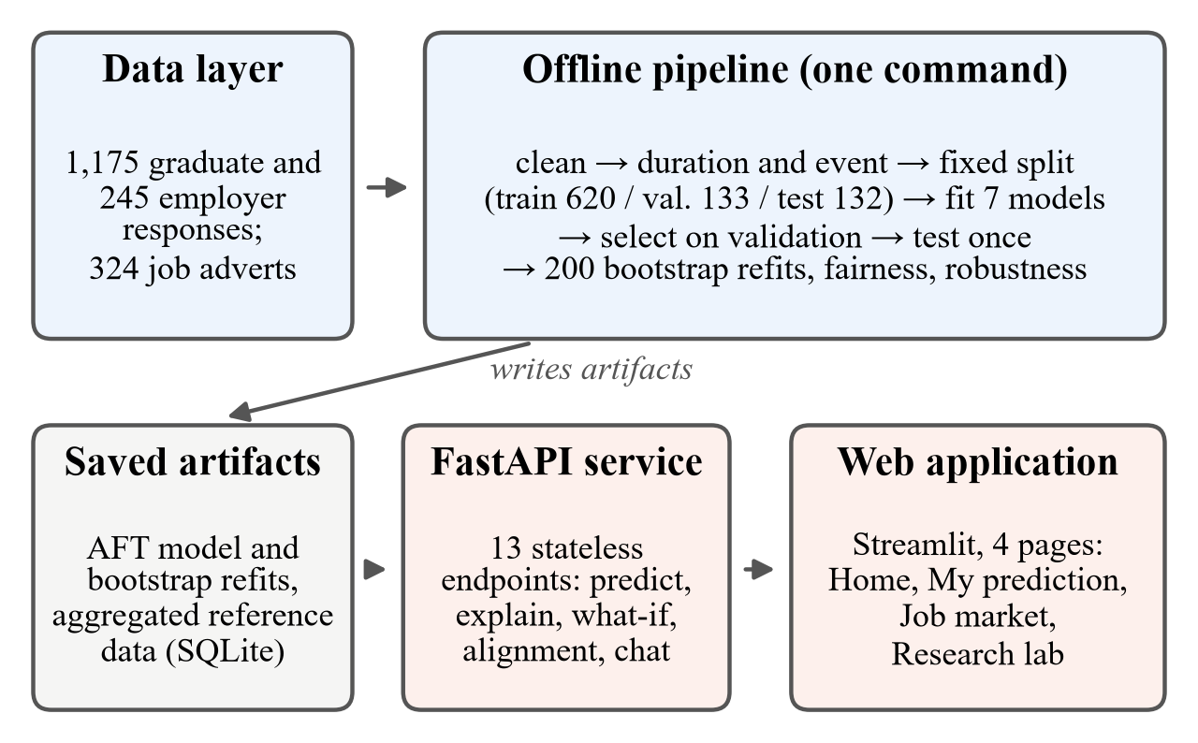
- Three-layer architecture of the decision-support system.

Prediction and Uncertainty
For a profile, the selected model gives an individual survival curve S(t), the probability of still searching at month t. The most likely time is where S(t) falls to 0.50, and the typical range runs from where it falls to 0.75 to where it falls to 0.25; a level not reached within follow-up is reported as “more than” the horizon rather than extrapolated. The same calculation on the 200 bootstrap models gives an 80% interval, from which a High, Medium or Low confidence label is assigned. For a graduate who has already searched m months, the curve is conditioned on still searching:
S(t | T > m) = S(t) / S(m). (2)

Explanation, What-If and Market Alignment
Each factor's contribution is its coefficient multiplied by the difference between the profile and the average training graduate (SHAP values for a neural model), and only factors a graduate can change are listed, at most three helping and three holding back. The what-if module re-predicts the profile after realistic changes and warns when a value lies outside the training range, and a search over small combinations of changes returns up to three suggestions linked with finding work at least one month sooner. The alignment module compares the graduate's rating of each of the 26 skills with the employers' mean importance and the share of advertisements naming it. All wording is associational (“graduates with profiles like yours tended to…”) and states the limits of the estimate. A chat assistant answers questions about the result using only these outputs, without a language model.

Implementation
The system was built in Python 3.11 with lifelines and scikit-survival for the Cox, Elastic Net and AFT models, pycox on PyTorch for DeepSurv, SHAP for neural explanations, FastAPI for the service, Streamlit for the interface and SQLite for the read-only reference data. Streamlit and SQLite replaced the planned Next.js and PostgreSQL so that a single developer could build and test the dashboard within the timeline. Random seeds are fixed, so the whole analysis is reproduced exactly from the raw files, and 295 automated tests cover outcome construction, leakage, range ordering and every endpoint. The source code is available at https://github.com/ShaznaSalman/final-research-employability-survival_COBSCCOMP24.2P019.

Evaluation and Results

Time to First IT Job and Associated Factors
Of the 885 modelling graduates, 43.6% had found an IT job within 3 months of completing their degree, 67.0% within 6 months, 80.9% within 12 months and 89.8% within 24 months (Kaplan-Meier); the median was 4 months. On the training set, log-rank tests showed clear differences by GPA (median 4 months for a GPA of 3.0 or higher against 7 months below 3.0; p < 0.001, Fig. 2), internship (p = 0.003) and portfolio (p = 0.006), but not by institution type (p = 0.84) or degree group (p = 0.47).
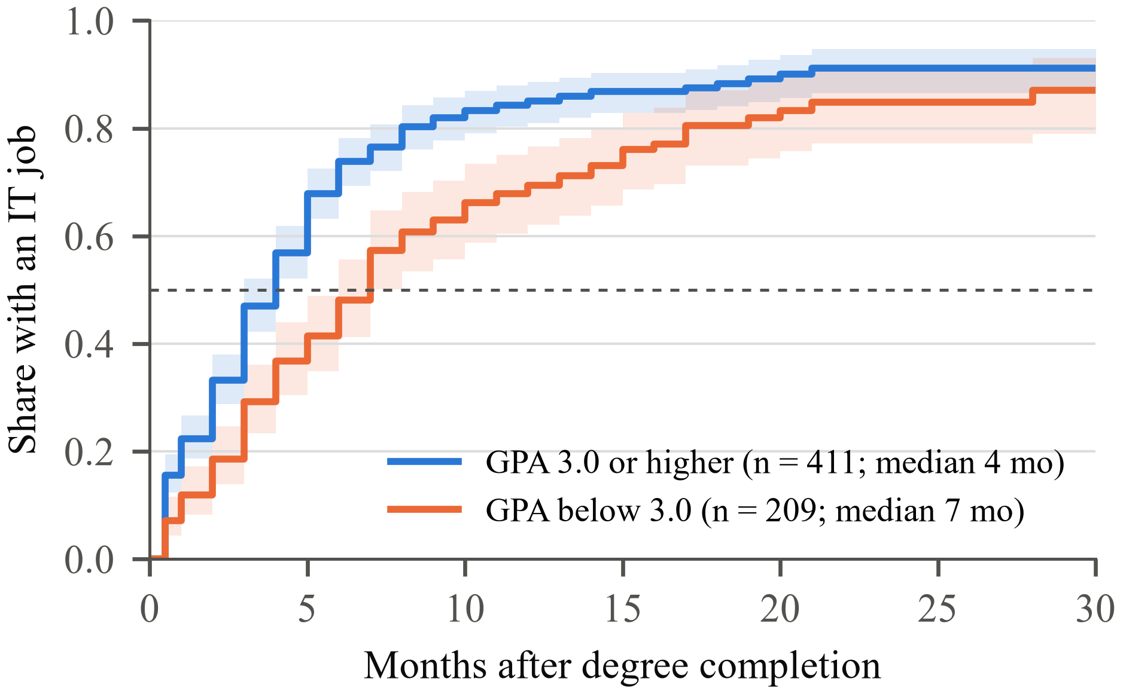
- Share of training graduates who had found an IT job, by GPA (Kaplan-Meier estimate with 95% confidence band).
After adjustment (Table II), only GPA and internship experience were clearly associated with the outcome: one standard deviation higher GPA (about 0.4 points) was associated with a 20% shorter time and one standard deviation more internship (about 3.5 months) with a 16% shorter time. Both remained significant after Holm correction for the 16 coefficients tested (adjusted p = 0.022 and 0.021). Certifications and technical skills pointed the same way but their intervals included no effect. No predictor violated the proportional-hazards assumption (all Schoenfeld p > 0.10).
- Adjusted Associations with Time to First IT Job (Training Set, n = 620, 467 Events)
Factor (numeric: per one SD) | Cox hazard ratio (95% CI); > 1 = sooner | AFT time ratio (95% CI); < 1 = sooner
GPA | 1.24 (1.10–1.40) | 0.80 (0.70–0.92)
Internship months | 1.12 (1.03–1.23) | 0.84 (0.76–0.94)
Certifications | 1.09 (1.00–1.19) | 0.95 (0.86–1.05)
Projects outside coursework | 1.07 (0.95–1.20) | 0.98 (0.86–1.11)
Technical skill score | 1.13 (0.98–1.31) | 0.92 (0.79–1.08)
Soft skill score | 0.98 (0.87–1.12) | 0.97 (0.85–1.10)
Six preparation items | 0.93 to 1.02 (all include 1) | 0.95 to 1.06 (all include 1)
Non-state vs state institution | 1.14 (0.88–1.47) | 0.86 (0.65–1.14)
SD: standard deviation; CI: confidence interval. Degree group and foreign-affiliated institutions also showed no clear association.

Graduate, Employer and Market Alignment
Employers rated 25 of the 26 skills as more important than graduates rated their own proficiency at completion, significantly so for 24 skills after false-discovery-rate correction (Mann-Whitney U; 1,115 graduates including final-year students, 239 employers). The largest gaps were in cloud computing, software testing, DevOps and Docker (Fig. 3). The advertisements asked most often for problem solving (69%), teamwork (61%) and communication (55%) and, among technical skills, for software testing (44%), SQL (37%) and REST APIs (33%). Employers' stated priorities and their advertisements showed only a weak, non-significant relationship (Spearman ρ = 0.39, p = 0.052). The gap compares self-rated proficiency with employer-rated importance, so it shows where graduates fall short of what employers value rather than an exact deficit. Employers ranked technical depth, problem solving and interview performance highest among hiring factors and rated GPA (3.21 of 5) and certifications (3.25) least important.
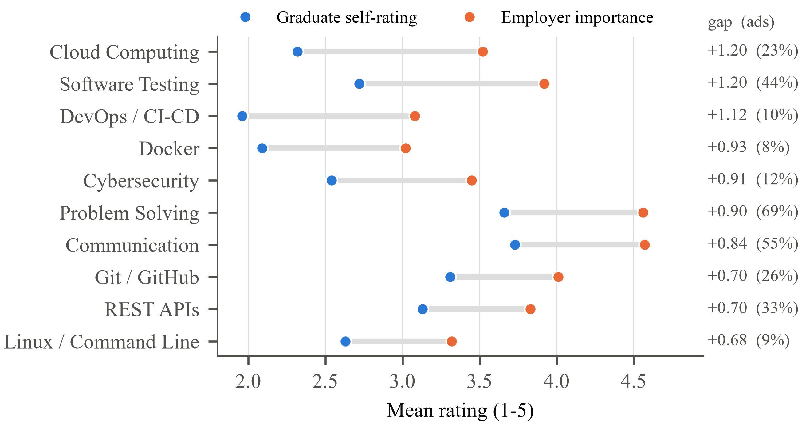
- The ten largest gaps between employers' importance ratings and graduates' self-ratings at completion, with the share of the 324 job advertisements naming each skill.

Model Comparison and Final Evaluation
All seven models discriminated well above chance on the validation set (Fig. 4). The log-normal AFT model had the highest Uno's C (0.693) and the joint-lowest IBS (0.171, with the log-logistic model) and was selected by the pre-set rule. It also fitted the training data best (AIC 2,724.8 against 2,729.8 for log-logistic and 2,766.7 for Weibull), because time to a first job is strongly right-skewed and the log-normal hazard can rise soon after completion and then fall for those still searching. The intervals overlap substantially, so the ranking should not be over-interpreted.
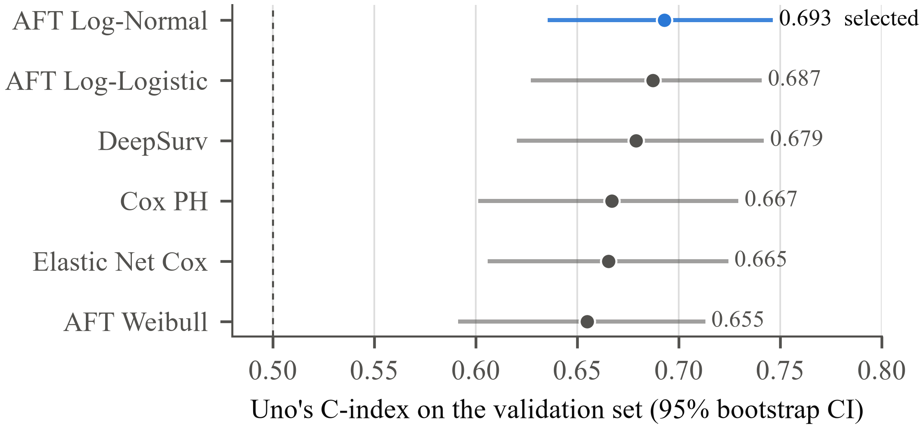
- Uno's C-index of the candidate models on the 133 validation graduates.
Evaluated once on the 132 test graduates, the selected model reached Uno's C = 0.619 (95% CI 0.557–0.683) and Harrell's C = 0.626: of two test graduates, it correctly ranked which found work first about 62 times in 100. Table III checks the result against the conditions fixed before analysis. The model ranks graduates, but its IBS was no lower than the baseline and it under-predicted employment, for example 61% predicted against 77% observed by 6 months. The training C (0.613) was close to the test C, whereas the validation C was higher because the best of seven models was chosen on only 133 graduates, so the test result is the better estimate.
- Pre-Set Conditions and Evidence on the Locked Test Set
Condition | Evidence | Met?
Better than no model | C 95% CI 0.557–0.683, above 0.5; IBS 0.167 vs 0.164 for Kaplan-Meier | Partly
Calibrated probabilities | Under-prediction of 15, 17 and 8 points at 3, 6 and 12 months | No
Stable results | Validation C 0.693 vs test 0.619; intervals overlap | Partly
Transfer across institutions | Fitted without one type: C 0.702, 0.695, 0.658 | Yes
Assumptions hold | No Schoenfeld violation; AFT family chosen by AIC | Yes
Not overfitted | Training C 0.613 vs test 0.619 | Yes
Fair across groups | Women C 0.724, men 0.574 (men's CI 0.480–0.650 includes 0.5) | Partly
Within the data | Out-of-range cautions; no extrapolation beyond follow-up | Yes

Robustness, Fairness and System Performance
Across alternative data decisions (timing of jobs before completion, excluding 118 rounded recall times, complete cases, multiple imputation) validation C ranged from 0.659 to 0.707 and no clear association changed direction (only the specialised-degree group, with no clear effect, moved from a hazard ratio of 1.06 to 1.00 in complete cases). Trained on cohorts completing up to August 2025 and tested on later cohorts, the model reached C = 0.721 but again under-predicted early employment. Three further neural models (DeepHit 0.590, Cox-Time 0.674, N-MTLR 0.666) did not improve on it, and a learning curve levelled off near 0.69, suggesting that more respondents answering the same questions would add little. On the test set C was 0.724 for women and 0.574 for men, with overlapping intervals; gender is never a model input. The explanation contributions summed exactly to each prediction, and the direction of the leading contributions agreed in 76–100% of bootstrap refits. All 295 automated tests pass; median response time was 56 ms for a prediction and 263 ms for the slowest endpoint, well within the one-second target.

User Evaluation
In the main survey, 64.3% of graduates said they would use such a system before applying for jobs and 70.3% of employers rated it useful, and the explanations graduates most wanted, the skills they need to improve, are those the artifact provides. To test whether the model adds value over a general-purpose large language model (LLM), the 132 test profiles, without outcomes, were entered into ChatGPT (GPT-5.6, free tier, 14 October 2026), each in a new temporary chat; 30 profiles were entered three times, giving 192 answers, all of them usable. ChatGPT's Uno's C was 0.539 against 0.619 for the model on the same graduates (difference 0.081, paired bootstrap 95% CI 0.030 to 0.131). It expected every graduate outside the slowest third to be employed within six months, against 71-80% observed, and gave identical answers in all three runs for only one of the 30 repeated profiles. Twelve final-year students and recent graduates who had not answered the survey then used the application in one-to-one sessions and completed the SUS. The mean score was 76.3 (SD 10.6, 95% CI 69.5 to 83.0; range 60.0 to 92.5), above the benchmark of 68 [27] (t(11) = 2.70, p = 0.021), and 10 of the 12 participants scored 68 or more (Cronbach's alpha 0.90). The weakest items were how well the functions fitted together and how much had to be learnt before starting; participants asked for less information on one page, plain explanations of terms such as "confidence" and a short guide at the start, and valued most the comparison of their skills with employer and job-advertisement demand.

Discussion
Survival analysis was the appropriate frame. A quarter of the modelling graduates (24.6%) were still searching when surveyed. A classification approach would have had to discard them or count them as failures; survival analysis used the information that they had not yet found work by a given month, and its output, a time range and the chance of employment by fixed months, is closer to the question graduates ask. A single employment rate at one point in time, as in tracer studies [28], hides this spread.
Academic performance and internships mattered; institution type did not. This is consistent with the multidimensional view of employability [6], [7]. It is notable that employers rated GPA as the least important hiring factor, yet GPA had the strongest association with time to employment. GPA may act as a screening signal at the shortlisting stage, or it may proxy for unmeasured effort and ability; because the study is observational, the associations must not be read as causal. Self-rated skills added little, which agrees with evidence that perception-based skill data identify gaps better than they predict outcomes [15], [16].
Simple models were as accurate as complex ones. Neither DeepSurv nor three further neural models improved on the parametric AFT model, which agrees with the observation that deep survival models need large samples [21] and with a large neutral comparison in which no method clearly beat the Cox model on low-dimensional data [29]. The remaining variation most likely reflects factors not measured, such as personal networks, job-search effort and interview performance, which employers themselves ranked highly. The practical implication is positive: the most interpretable model is also the best supported.
The model ranks graduates, but its probabilities are too pessimistic. Small evaluation sets, faster hiring of later cohorts and the single reference survey date, which may lengthen the follow-up of graduates still searching, are plausible reasons. Reporting this rather than tuning the model until the test result improved follows the design fixed in advance [26], and the artifact therefore presents ranges as its main result and labels probabilities as indicative. The skill gaps match those reported by industry [1] and the curriculum lag described in the literature [3], [4], although at entry level employers advertise foundations and the ability to learn more than emerging specialisms.
Limitations. Skills and outcomes were self-reported and dates were recalled; the sample is non-probability, with about a third of responses from one institution; one reference survey date was used; and the evaluation sets were small, so the results do not generalise statistically to all Sri Lankan IT graduates. The usability evaluation had 12 participants recruited from the researcher's peers, which may favour positive ratings.

Conclusion and Recommendations
This study set out to give Sri Lankan IT graduates an explainable, individual estimate of their time to a first IT job, linked to real labour-market demand and with transparently established accuracy. Using 1,175 graduate and 245 employer responses and 324 job advertisements, it found that most graduates found IT work within about four months, that GPA and internship experience were the factors most clearly linked with a shorter search, and that graduates fall short of employer expectations most in modern engineering practice, problem solving and communication. A parametric AFT model was as accurate as any neural alternative and the most interpretable, but its accuracy on unseen graduates was moderate, a limit set more by what surveys measure than by the algorithm. The study contributes a reproducible, explainable time-to-employment framework, a working decision-support application that users rated as usable (mean SUS 76.3) and that ranks graduates better than a general-purpose LLM, and a current, triangulated picture of entry-level IT skill demand in Sri Lanka. The following actions are recommended:
- Graduates: complete a substantial internship, protect academic performance, build practical skill in software testing, SQL, REST APIs and Git, and prepare for interviews and for explaining technical work in English.
- Universities: embed testing, version control, APIs, cloud and DevOps practice in project modules, and track graduates' time to a first job with month-level questions.
- Employers: state entry-level requirements clearly by role, since stated priorities and advertisements agreed only moderately.
- Developers of similar systems: keep the test set separate from every modelling decision, compare against a no-model baseline and a simple model, and report calibration as well as ranking.
Future work should measure job-search effort, referrals and interview performance, record exact response and employment dates, and recalibrate and re-evaluate the model on a new graduate cohort followed from the final year.

Acknowledgment
This research was carried out at the School of Computing and Engineering, National Institute of Business Management (NIBM), Sri Lanka, as part of the BSc (Hons) in Computing programme, and the research belongs to NIBM. The authors thank the graduates and employers who responded to the surveys and the six expert reviewers of the instruments. The research received no external funding.

References
- SLASSCOM, “Employability skills report 2024,” Sri Lanka Association of Software and Service Companies, Colombo, Sri Lanka, 2024.
- Department of Census and Statistics, “Sri Lanka labour force survey: Quarterly bulletin, first quarter 2025,” Issue no. 108, Colombo, Sri Lanka, 2025.
- N. R. Aljohani, A. Aslam, A. O. Khadidos, and S.-U. Hassan, “Bridging the skill gap between the acquired university curriculum and the requirements of the job market: A data-driven analysis of scientific literature,” J. Innov. Knowl., vol. 7, no. 3, Art. no. 100190, 2022.
- P. M. D. S. Amarasooriya, “Analysis of future demand for Sri Lankan ICT undergraduates in ICT industry: Mapping the ACM/IEEE computing degrees with emerging technologies,” SSRN preprint 4811746, 2024.
- S. L. M. Rukais, S. Adeeba, G. A. C. A. Herath, and B. T. G. S. Kumara, “An ensemble model for predicting career paths of Sri Lankan IT undergraduates,” IEEE Access, 2025.
- M. Tomlinson et al., “Developing graduate employability for a challenging labour market: The validation of the graduate capital scale,” J. Appl. Res. High. Educ., vol. 14, no. 3, pp. 1193–1209, 2022, doi: 10.1108/JARHE-04-2021-0151.
- D. Bennett and S. Ananthram, “Development, validation and deployment of the EmployABILITY scale,” Stud. High. Educ., vol. 47, no. 7, pp. 1311–1325, 2022.
- R. L. S. Fernando, E. A. I. Kularathna, and I. D. C. D. Kumarasinghe, “Employability of management graduates of state universities in Sri Lanka: Problems and prospects,” Int. J. Governance, Public Policy Admin., 2023.
- C. Samaradivakara, R. Bell, and A. Raghubansie, “The conceptualisation of employability among higher education administrators in Sri Lanka’s turbulent labour market,” High. Educ. Skills Work-Based Learn., 2024, doi: 10.1108/HESWBL-10-2023-0289.
- N. Gangoda, K. P. Yasantha, C. Sewwandi, N. Induvara, S. Thelijjagoda, and N. Giguruwa, “Resume Ranker: AI-based skill analysis and skill matching system,” IEEE Access, 2024.
- S. K. Parimi, R. Cherukuri, V. K. Yarram, and B. Jegajothi, “AI-assisted web platform for personalized job recommendation using machine learning techniques,” IEEE Access, 2025.
- K. R. D. S. K. Karunanayake et al., “ITConnect: Real-time personalized job posting platform for IT professionals,” in Proc. 8th Int. Conf. Information Technology Research (ICITR), 2023, doi: 10.1109/ICITR61062.2023.10382750.
- M. Roy and K. Sharma, “AI-powered career guidance: A scalable model for personalized recommendations,” IEEE Access, 2026.
- B. Sribharathi, S. Balamurugan, S. Megavarmaraj, S. Deepak, and S. Kajendhiran, “Scopira: An AI-driven career guidance system using resume parsing, skill gap analysis, and intelligent job matching,” IEEE Access, 2025.
- B. Ning, “Leveraging predictive analytics for skill gap analysis in undergraduate career management systems,” IEEE Access, 2025.
- J. W. Lai, L. Zhang, C. C. Sze, and F. S. Lim, “Learning analytics for bridging the skills gap: A data-driven study of undergraduate aspirations and skills awareness for career preparedness,” Educ. Sci., vol. 15, no. 1, Art. no. 40, 2025, doi: 10.3390/educsci15010040.
- M. Alemu and B. Yismaw, “Understanding waiting time from graduation to first employment: Survival analysis-based evidence from Ethiopia,” Educ. Res. Int., vol. 2022, Art. no. 9001679, 2022, doi: 10.1155/2022/9001679.
- C. Lalley, “Time to graduate level employment for new graduates in the United Kingdom,” Kyklos, vol. 78, no. 3, pp. 1091–1104, 2025, doi: 10.1111/kykl.12460.
- A. Tarkhan and N. Simon, “An online framework for survival analysis: Reframing Cox proportional hazards model for large data sets and neural networks,” Biostatistics, vol. 25, no. 1, pp. 134–153, 2024.
- Z. Zhao, J. Zobolas, M. Zucknick, and T. Aittokallio, “Tutorial on survival modeling with applications to omics data,” Bioinformatics, vol. 40, no. 3, Art. no. btae132, 2024, doi: 10.1093/bioinformatics/btae132.
- S. Wiegrebe, P. Kopper, R. Sonabend, B. Bischl, and A. Bender, “Deep learning for survival analysis: A review,” Artif. Intell. Rev., vol. 57, no. 3, Art. no. 65, 2024, doi: 10.1007/s10462-023-10681-3.
- R. R. Hoffman, S. T. Mueller, G. Klein, and J. Litman, “Measures for explainable AI: Explanation goodness, user satisfaction, mental models, curiosity, trust, and human-AI performance,” Front. Comput. Sci., vol. 5, Art. no. 1096257, 2023, doi: 10.3389/fcomp.2023.1096257.
- E. Mosca, F. Szigeti, S. Tragianni, D. Gallagher, and G. Groh, “SHAP-based explanation methods: A review for NLP interpretability,” in Proc. 29th Int. Conf. Comput. Linguistics, 2022, pp. 4593–4603.
- T. Haryanti, N. A. Rakhmawati, and A. P. Subriadi, “Measuring the digital transformation maturity level independently with the design science research methodology,” Syst. Eng., vol. 27, no. 1, pp. 159–176, 2024, doi: 10.1002/sys.21714.
- G. S. Collins et al., “TRIPOD+AI statement: Updated guidance for reporting clinical prediction models that use regression or machine learning methods,” BMJ, vol. 385, Art. no. e078378, 2024, doi: 10.1136/bmj-2023-078378.
- R. Sonabend, A. Bender, and S. Vollmer, “Avoiding C-hacking when evaluating survival distribution predictions with discrimination measures,” Bioinformatics, vol. 38, no. 17, pp. 4178–4184, 2022, doi: 10.1093/bioinformatics/btac451.
- M. Hyzy et al., “System Usability Scale benchmarking for digital health apps: Meta-analysis,” JMIR mHealth uHealth, vol. 10, no. 8, Art. no. e37290, 2022, doi: 10.2196/37290.
- University of Kelaniya, “Graduate employability 2021,” University Statistics and Data Monitoring Unit, Kelaniya, Sri Lanka, 2022.
- L. Burk, J. Zobolas, B. Bischl, A. Bender, M. N. Wright, and R. Sonabend, “A large-scale neutral comparison study of survival models on low-dimensional data,” arXiv:2406.04098, 2024.

